1. ERD

The relationship diagram entity is the crucial part of the technology used to the arrange and display the medical data for to the analytics of this project. Erd facilitates communication between medical records, healthcare providers, and patients. Because properly utilizing ERDs guarantees sound data management, improves data quality, and facilitates adherence to the privacy regulations of the Oracle (2021) claims that by offering a transparent, to the scalable architecture for the handling enormous volumes of healthcare data, a clear ERD can enhance decision-making and lower database design errors.

Fig:- The healthcare system's Erd diagram

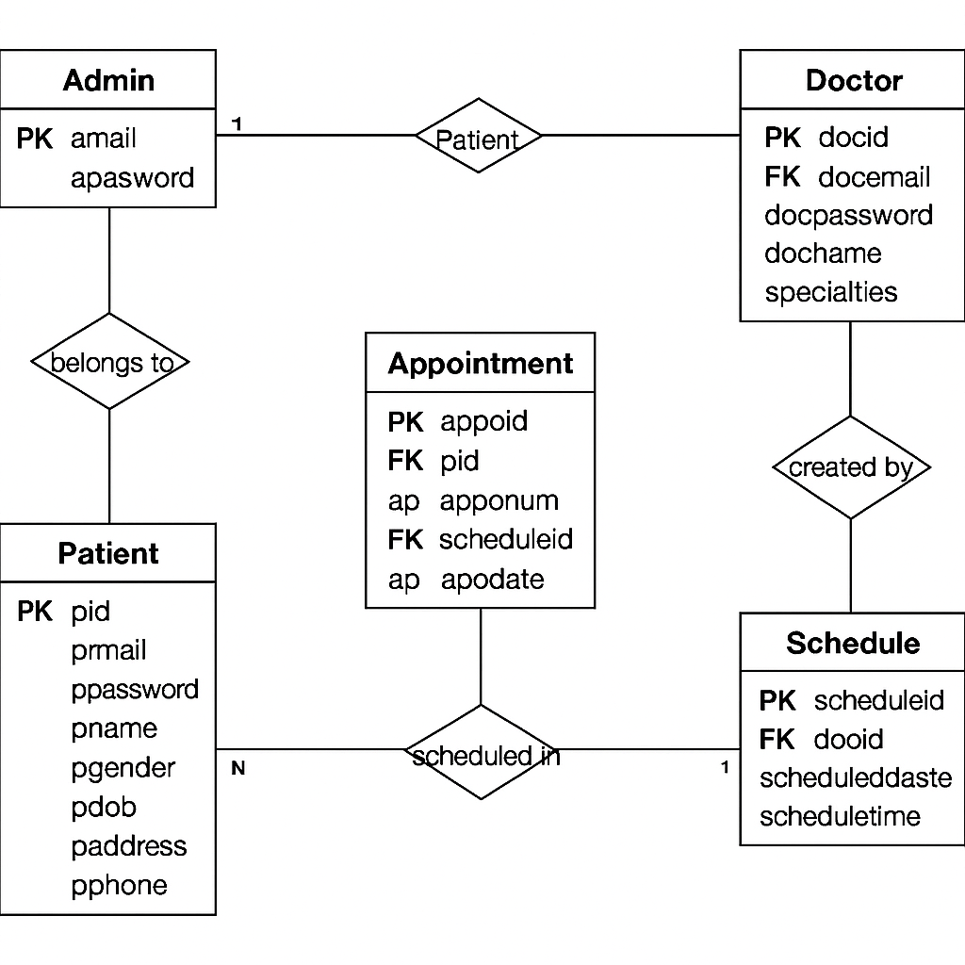

Fig:- The Web application system's Erd diagram